# COMP3500: Midterm Exam 1 – Exercises

**Exercise 1:** Two processes cooperate in computing the sum of the first N odd integers. Add appropriate semaphore declarations and signal and wait statements to these programs so that the proper value of Sqr (i.e., 25) will be printed out.

1+3+5+7+9=25 Process Q: Sqr=Sqr + 2*N-1

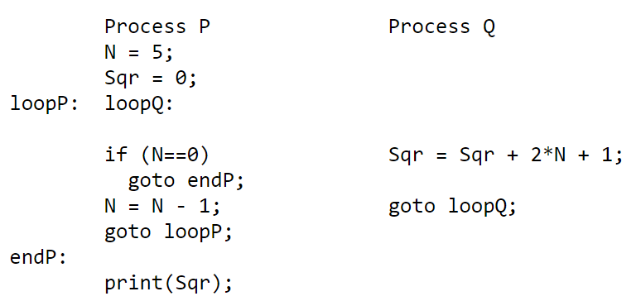

Solution:

semaphore sqr_add = 0, N_minus = 1;

loopP: loopQ:

wait(sqr_add);

if (N==0)

goto endP

N = N-1;

signal(N_minus);

goto loopP;

endP:

print(Sqr);

Process Q

wait(N_minus);

Sqr = Sqr + 2N + 1;

signal(sqr_add);

goto loopQ;

**Another solution!**

loopP: loopQ:

if (N==0)

goto endP

wait(sqr_add);

N = N-1;

signal(N_minus);

goto loopP;

endP:

wait(sqr_add);

print(Sqr);

**Exercise 2:** The Cigarette Smoker's Problem. There are three smokers and one cigarette dealer. A smoker must make a cigarette before he or she can smoke it. Making a cigarette requires (1) tobacco, (2) paper, and (3) matches. Each smoker has one of the three items. Specifically, one smoker has tobacco, another has paper, and a third one has matches. The cigarette dealer has an infinite supply of tobacco, paper, and matches. The dealer randomly selects two of the three items and places them on a table. Then, the smoker who has the third item makes a cigarette and smoke. After the first smoker finishes smoking, the dealer will place other two of the three items on the table so that another smoker can enjoy cigarettes. Please use semaphores to synchronize the three smokers and the dealer.

**Solution:**

Dealer

1 do forever {

2 wait( lock );

3 randNum = rand( 1, 3 ); // Pick a random number from 1-3

4 if ( randNum == 1 ) {

5 // Put tobacco on table

6 // Put paper on table

7 signal( smoker_match ); // Wake up smoker with match

8 } else if ( randNum == 2 ) {

9 // Put tobacco on table

10 // Put match on table

11 signal ( smoker_paper ); // Wake up smoker with paper

12 } else {

13 // Put match on table

14 // Put paper on table

15 signal ( smoker_tobacco ); } // Wake up smoker with tobacco

16 signal( lock );

17 wait ( smoker_done ); // Agent sleeps

18 } // end forever loop

One of the smokers. The others are similar.

1 do forever {

2 wait ( smoker_tobacco ); // Sleep right away

3 wait ( lock );

4 // Pick up match

5 // Pick up paper

6 signal ( smoker_done );

7 signal ( lock );

8 // Smoke (but don't inhale).

9 }